Customer Segmentation:

## Omit Some Product Class?

Line of business has 5 levels {Unknown, Food Services, HVAC, Miscellaneous, and Refrigeration} moving to the Product Class the levels grows to 26 levels and this may be too many levels.

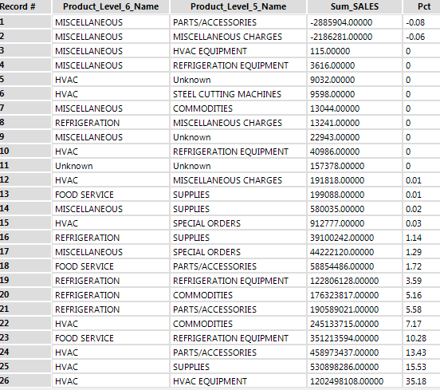

I recommend dropping the following:

Miscellaneous – Parts/Accessories  
Miscellaneous – Miscellaneous Charges   
HVAC – Steel Cutting Machines

Group all Commodities under its own.  
Group all Special Orders under its own.  
Group all Refrigeration Equipment under its own.

Generating the new groups, we get:

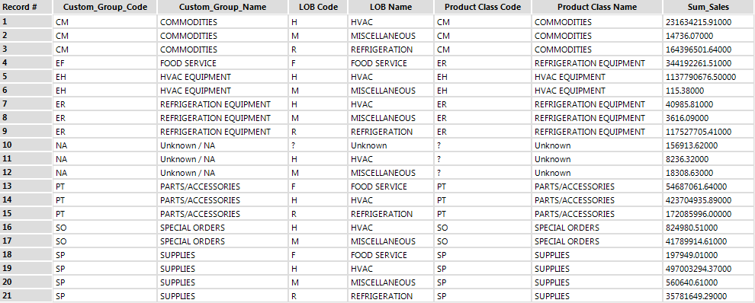

## Principal Components